Laplace and z Transforms
Transform Pairs

f(t) | F(s) | F(z)
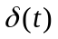 | 1 | 1
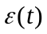 |  | 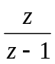
t | 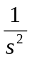 | 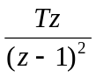
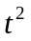 | 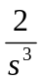 | 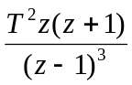
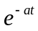 | 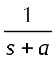 | 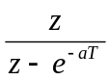
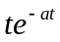 | 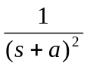 | 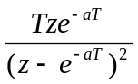
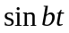 | 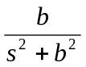 | 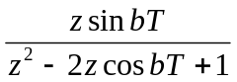
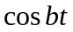 | 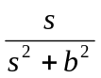 | 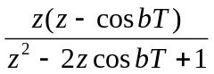
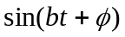 | 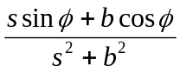 | 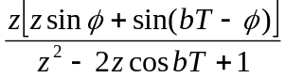
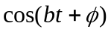 | 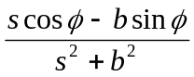 | 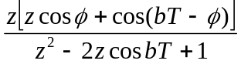
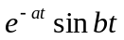 | 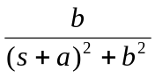 | 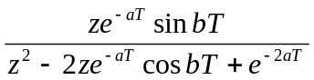
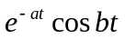 | 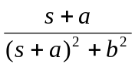 | 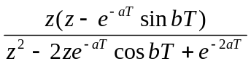
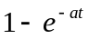 | 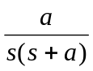 | 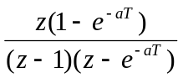
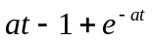 | 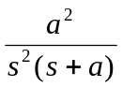 | 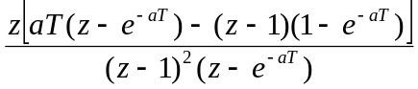
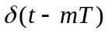 | 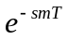 | 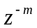
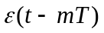 | 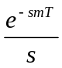 | 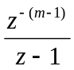
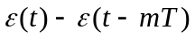 | 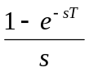 | 1

Properties Overleaf

Laplace and z Transforms
Properties

f(t) | F(s) | F(z)
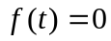 for 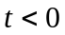 | 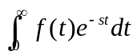 | 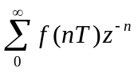
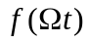 | 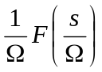
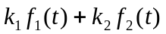 | 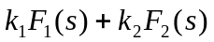 | 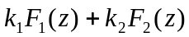
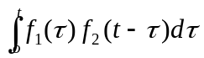 | 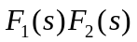
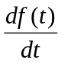 | 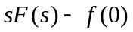
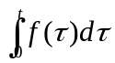 | 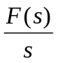
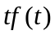 | 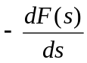 | 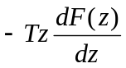
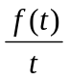 | 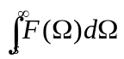
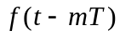 | 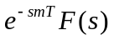 | 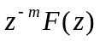
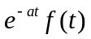 | 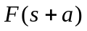 | 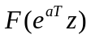
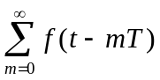 | 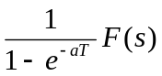 | 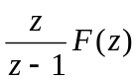
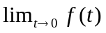 | 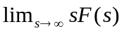 | 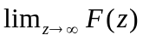
 | 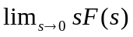 | 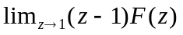

Transform Pairs Overleaf

